IDIS
(Iowa Drug Information Service)

February 2009

The IDIS database contains bibliographic records to articles on human drug therapy published since 1965.

It covers about 200 English-language journals and describes the drugs, diseases, and clinical concepts reported in the article.

IDIS features controlled vocabulary indexing with over 6600 specific drug terms, over 2400 disease/condition terms and over 100 descriptor terms that include the age group of the study population, study design, treatment efficacy, dosage, administration techniques, pharmacokinetics, pharmacodynamics, pharmacoeconomics, pharmaceutics, incompatibilities, drug interactions, toxicology, and side effects.

Animal studies are not indexed.

A distinctive feature of IDIS is that there is an article number for each record in the database that will lead you to a copy of the full text of the article. For articles published since 1989, the article number is an active link in the database; that is, if you click on the number, you will open up a .pdf copy of the article that can then be printed. For articles published before 1989, copy the Article Number and we can obtain a copy through interlibrary loan.

IDIS can be accessed by anyone with a current Wilkes username and password. Log into the Wilkes Portal and click on the Libraries tab. Go to the PIC channel and click on Electronic Resources. (Note the separate link if you are connecting from off-campus.)

When you get to the IDIS login page, click on the login button in the center left. (Do NOT enter any terms in the username/password boxes here since we use IP authentication.)

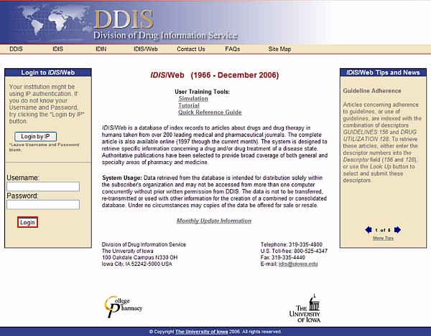
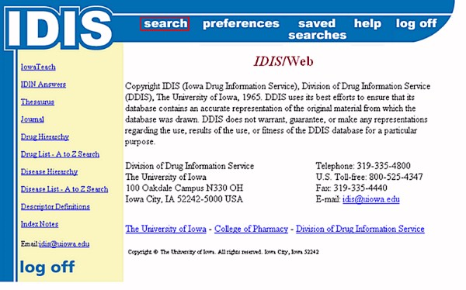

The main page is loaded, from which you can access the database by clicking Search. Important information will occasionally be posted on this page as well as Tips and News.

Notice the Log Off at the bottom left. We have a subscription for only 4 users at a time. It is very important that you log out when you are done instead of just Xing out or someone else may not be able to access the system. Also, your session will be closed if you do not perform any activity for 20 minutes.

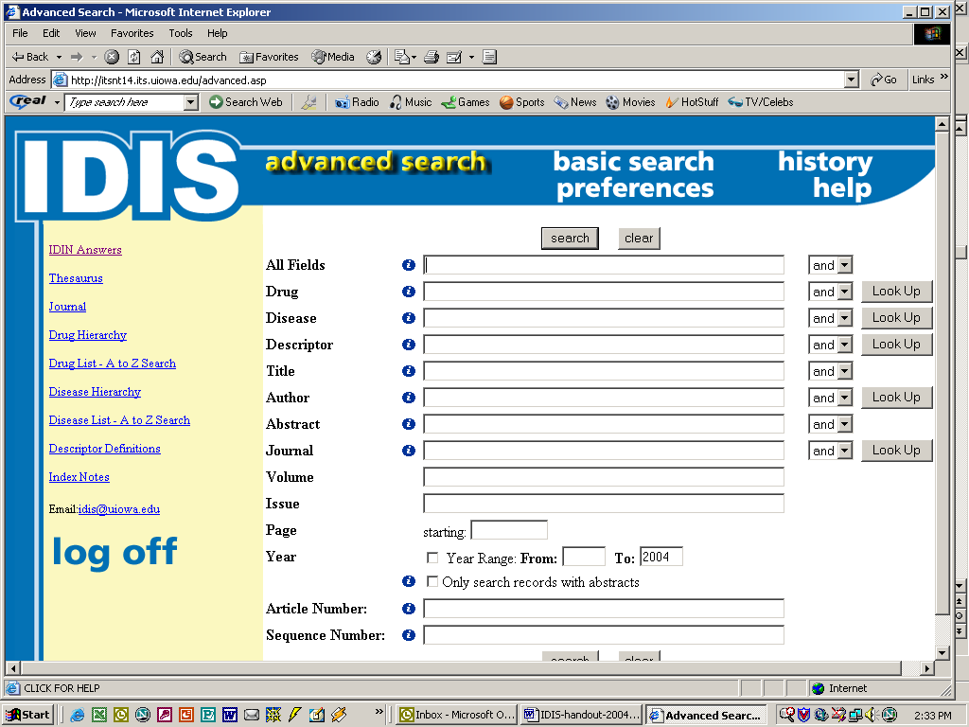

You can enter terms in any field on the Search screen. Multiple terms may be searched in a specific field. For example, to retrieve index records that contain both TRIMETHOPRIM and SULFAMETHOXAZOLE as drug terms in the Drug field, enter both terms connected with an AND in the Drug field.

Terms may be truncated to find all possible forms of the word by using the asterisk (*). For example, prescript*.
Some fields have Look Up buttons to the right. Use these to find the exact terms from the IDIS controlled vocabulary. Click on the Look Up button and enter your term/phrase in the search box on the next screen. Click Submit to display the list of valid vocabulary terms that match.
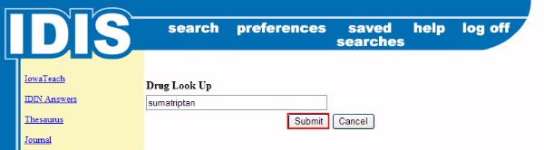
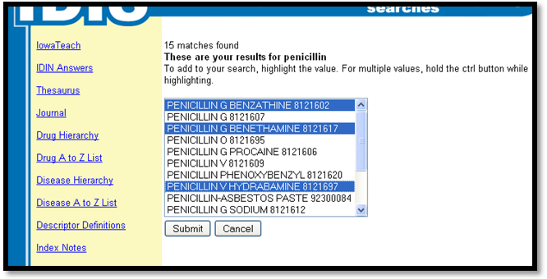
The vocabulary terms are displayed in a drop-down list. Click to highlight the entry(ies) you want to search, then click Submit. (To choose multiple terms, hold down the Control button while highlighting the terms.) The term(s) will be copied to the appropriate field on the Search screen.
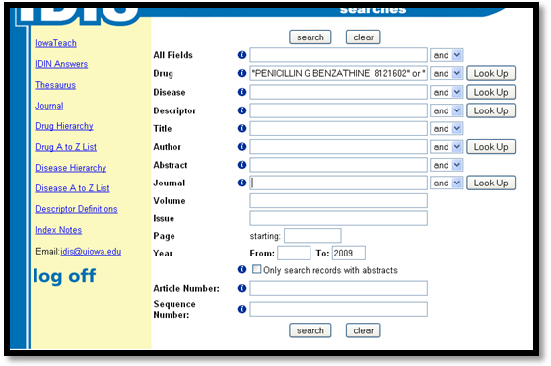
Notice that the term(s) and code(s) are placed within double quotation marks. Any time you use a compound search term (more than one word or number), it is important that you enclose the term in quotation marks to force adjacency and ensure a specific search.
If you wanted to search for another term, repeat the steps. The default Boolean operator within a field is "or." If you want to use the "and" operator, delete the "or" operator within the field and enter the "and" operator.

Different search terms may be entered in separate fields for combination field searching.
The Connection or Boolean box beside the field boxes is used to combine concepts in different fields. The default operator is AND. Click on the arrow in the box to change the value of the operator.

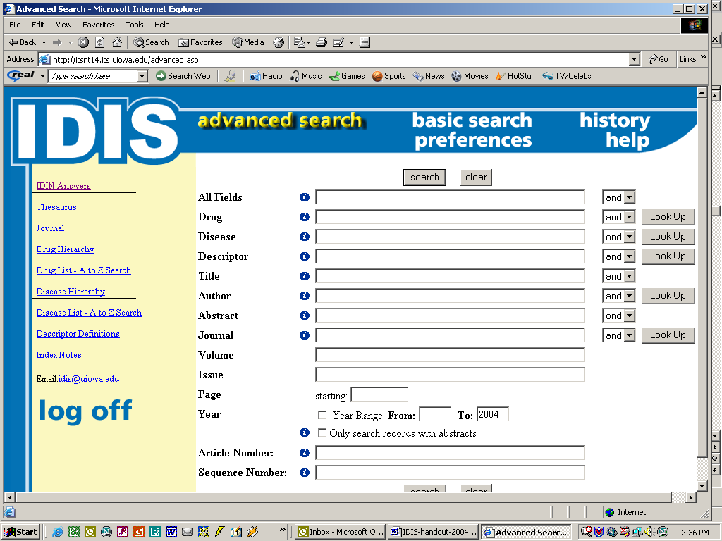

For the Drug and Disease fields, you may type any search term in the space. The program finds the authorized or valid term for you and automatically searches on it.

In the Drug field, only drugs that relate to the main focus of the article are indexed; other drugs in the same article may not be indexed. IDIS uses non-proprietary names; when possible, USAN is used. IDIS also uses the Drug field to index some special concepts of interest to users; these concepts are book reviews and software reviews.

For each article, the disease condition being treated is indexed and can be found through the Disease Field. The Disease terms are based on ICD-9 (International Classification of Diseases and Related Health Problems, 9th ed.) and include diseases and injuries, operations, procedures, diagnoses, conditions of external injury and poisoning, conditions of maternity and the newborn, and adverse reactions to chemical substances. Special population groups such as geriatrics and athletes are also listed with the Disease terms.

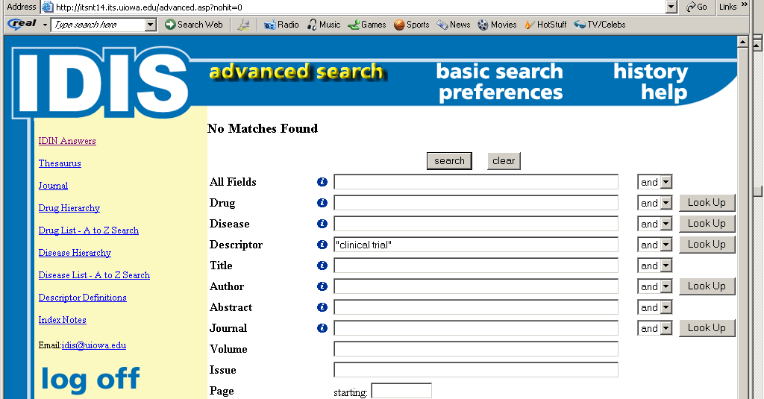

Descriptors are secondary indexing terms (drug and disease being the primary indexing terms) that further identify the contents reported in an article. There are specific descriptors for type of article, drug-induced side effects, administration techniques, pharmacokinetics, pharmaco-economics, toxicology and many other clinically-relevant topic areas.

When searching the Descriptor field, you must use valid terms (notice No Matches above); the computer will not do the cross-referencing for you. Use either the Look Up button next to the Descriptor field or the Thesaurus. All descriptor entries in the Thesaurus are preceded with a (DE). For example, if you are interested in drug-induced rashes, click on the Thesaurus and type “rash.” You will get 17 matches. Several are Disease terms, but 2 are references to drug-induced rashes with the appropriate Descriptor term and code.

If you select more than one descriptor, you can also choose the Boolean operator (AND, OR) from the Descriptor Look Up page.

Thesaurus Searching
To search the Thesaurus, enter the term in the field box and click on the submit button. (If searching a phrase, remember to put it in quotes.) The valid terms appear in uppercase and are followed by their code numbers. Use the check box and Submit button to enter the term(s) on the search screen.

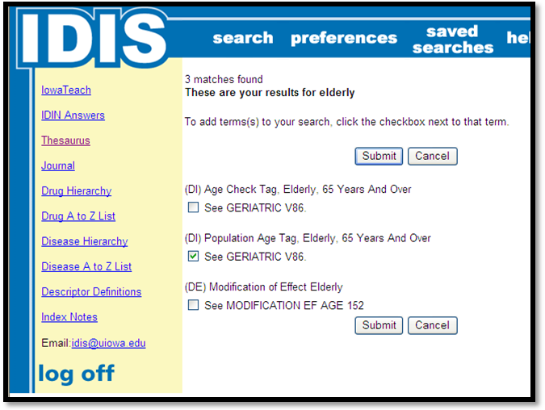

Search Limits
IDIS permits some limiting on the Advanced search screen.
- You may enter a range of years (e.g., 2000-2004 or 1999 to 1999).
- You may also restrict your retrieval to only those articles for which there is any abstract.

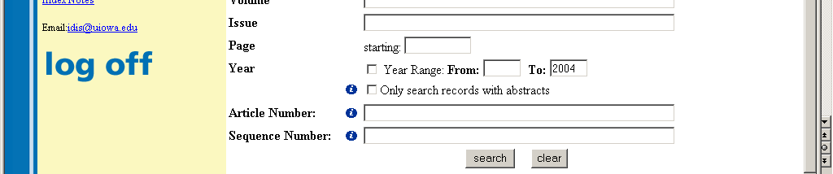
Codes and Truncation
When searching with valid terms, use either the valid term or code number. For example, the valid disease term and code number for congestive heart failure is FAILURE, HEART, CONGESTIVE 428.0. Either FAILURE, HEART, CONGESTIVE or 428.0 may be used for searching the disease term. The decimal point is part of the disease code number and must be entered in the search statement when using the disease code number. For a drug example, the valid drug term and code number for taxol is PACLITAXEL 10120090. Either PACLITAXEL or 10120090 may be used for searching the drug term. For a descriptor example, the valid term and code for gastrointestinal adverse effects of drugs is SIDE EF DIGESTIVE 78.

Since drugs assigned to a specific therapeutic class begin with the same code numbers, the entire therapeutic class of drugs can be searched by using the truncated drug code for that class (rather than searching each drug separately).
For example: HYPOTENSIVE AGENTS-ACE INHIB 24080200
PENTOPRIL 24080201
QUINAPRIL 24080202
CAPTOPRIL 24080203
.
.
.
FASIDOTRIL 24080242
To search for the entire class of Ace inhibitors, you could enter 240802*

To see what class a drug is in or to see a class, search in the Drug Hierarchy.

Author and Journal Searching
To search for a specific author, use the Author field in the Advanced Search screen. Authors are listed by last name, followed by up to three initials. Up to five authors (or four authors and et al) may be listed. When entering a name in the Author Field, the last name and all initials must be separated by a space and enclosed in quotation marks.

ex. “Lin A Y F”

A search can be limited to a specific journal by using the Journal field on the Advanced Search screen. Journal title abbreviations must be used in this field. If you do not know the correct title abbreviation, use the button beside the field and click on All journals. The Journal list also includes the years the journal has been indexed and any journal title change information.

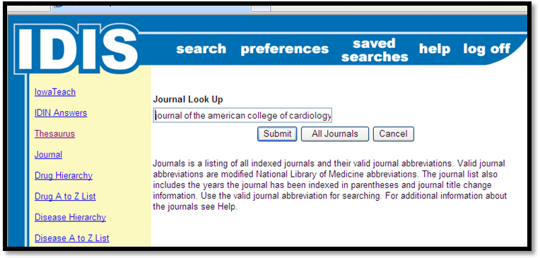

Display and Results
When you have performed a search, you will automatically be taken to the results page. The system will show you what terms it has searched and the citations and abstracts for the articles retrieved. The default is to show 25 citations. You may change either the number displayed or the format by clicking in the appropriate box, changing the value and then clicking on “Adjust.” To see the results on other pages, click on the page links.

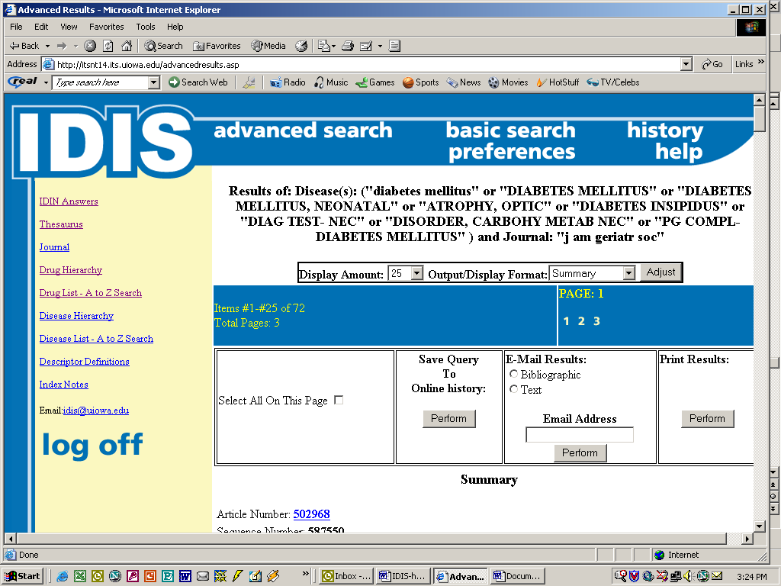
Once you have obtained the results and read the abstracts to choose the best articles(s) for your need, you may view the entire article(s) online by clicking on each relevant blue hyperlinked article number (for articles published after 1989).

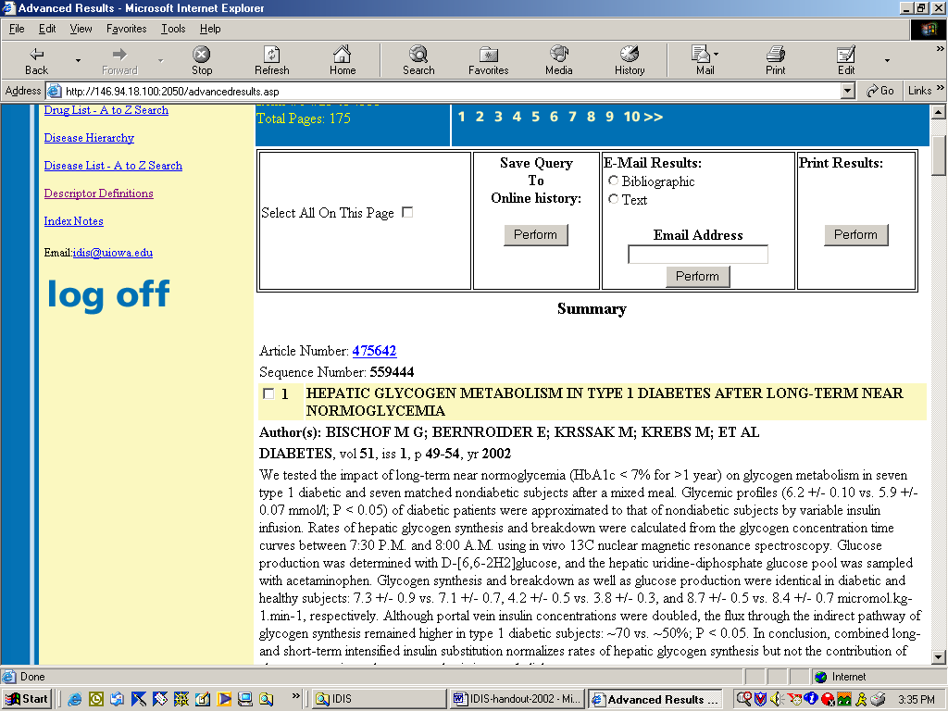

This will display the full article in .pdf format. For this to occur, you must have Adobe Acrobat Reader loaded on your computer. If you do not have this free program, you may download it from:
http://www.adobe.com/products/acrobat/

The IDIS Database goes back to 1966. The IDIS/Web articles are available full-text online only from 1989 on. We can get other articles through interlibrary loan.

You can read the article online, save it to a file or print a copy.
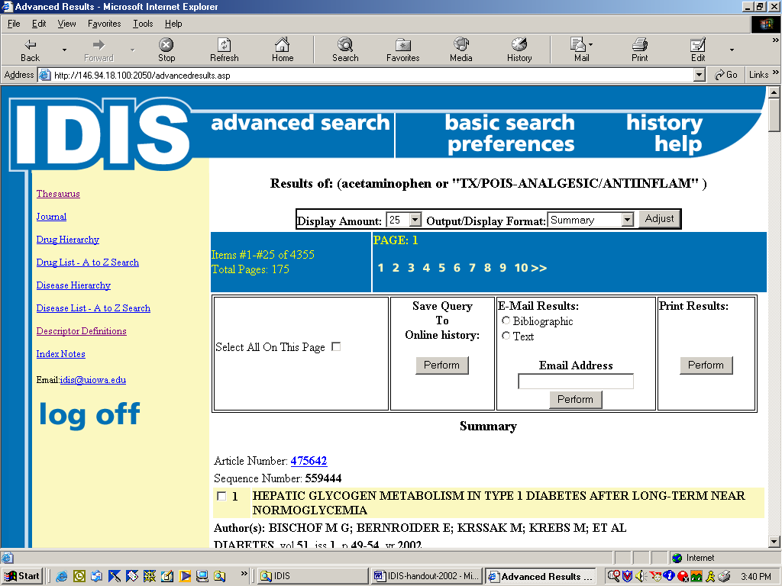

Alternatively, you may choose to just print the relevant citations and abstracts or e-mail them. Put a check in the box next to the article title(s) or choose “All on this page.”

To print, click on the “Perform” Print button.

